# Ensemble Techniques

**Instructions:**

Please share your answers filled in-line in the word document. Submit code separately wherever applicable.

Please ensure you update all the details:

**Name: _____________ Batch ID:** ___________

**Topic: Ensemble Techniques**

**Guidelines:**

**1. An assignment submission is considered complete only when the correct and executable code(s) and documentation explaining the method and results are submitted. Failing to submit either of those will be considered an invalid submission and not a correct submission.**

**2. Ensure that you submit your assignments correctly and in full. Resubmission is not allowed.**

**3. Post the submission you can evaluate your work by referring to the keys provided. (will be available only post the submission).**

**Hints:**

1. **Business Problem**
   1. **What is the business objective?**
   2. **Are there any constraints?**
2. **Work on each feature of the dataset to create a data dictionary as displayed in the below image:**

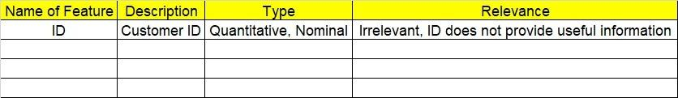**Make a table as shown above and provide information about the features such as its data type and its relevance to the model building. And if not relevant, provide reasons and a description of the feature.**

**Using Python codes perform:**

1. **Data Pre-processing**

**3.1 Data Cleaning, Feature Engineering, etc.**

**3.2 Outlier Treatment.**

1. **Exploratory Data Analysis (EDA):**
   1. **Summary.**
   2. **Univariate analysis.**
   3. **Bivariate analysis.**
2. **Model Building**
   1. **Build the model on the cleaned data.**
   2. **Experiment with Ensemble models to improve the reliability of Machine Learning model output**
   3. **Perform Bagging Boosting (adaboost, gradient boost, Xgboost), Stacking, and Voting on the given datasets in Hands-on Material.**
   4. **Train and Test the model and compare performances by capturing various metrics for experiments conducted with different hyperparameters. Also, use Hyperparameter optimization techniques (ex: GridSearchCV) to capture the best set of parameters for an improved model.**
   5. **Briefly explain the model output in the documentation.**
3. **Write about the benefits/impact of the solution - in what way does the business (client) benefit from the solution provided.**
4. **Deploy the final best solution for your client with UI.**

**Problem Statements:**

1. A cloth manufacturing company is interested to know about the different attributes contributing to high sales. Build a decision tree & random forest model with Sales as the target variable (first convert it into categorical variable).

